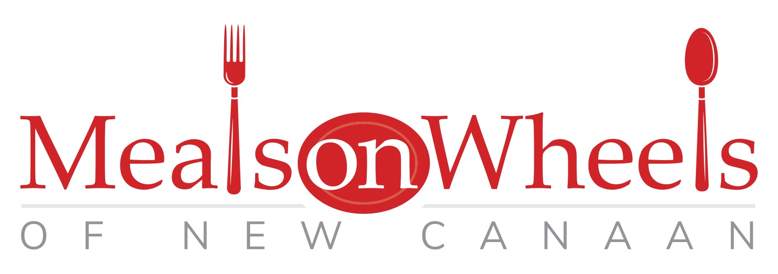
3 Farm Rd.,
New Canaan, Ct. 06840
203-594-5318
info@mowofnc.com

Volunteer Application

Name (Last) ____________________________ (First) ______________________________

Address_______________________________City/State___________________Zip_________

Cell phone________________________ Home phone_________________________________

Email______________________________ preferred method for last minute contact: _______

Emergency Contact__________________ Relationship_____________ Phone_____________

All Volunteers
Delivery of Meals takes about 1.5 hours to complete. Drivers, delivery partners, and substitute drivers are needed daily M-F including holidays from 10:45am - 12:30pm. Delivery drivers need dependable transportation, a current valid driver’s license and auto insurance.

*I am volunteering as a delivery partner and will not drive. I have not been arrested or convicted of larceny of any degree or convicted of any other misdemeanor or felony, in any degree, in any state or federal court of the United States or any other country.
Signature________________________

For Volunteer Drivers
As a Volunteer Driver for Meals on Wheels of New Canaan I understand that I must utilize my own privately owned vehicle for deliveries and maintain the state mandated minimum liability insurance on the vehicle being used for meal deliveries. I affirm that my physical abilities and past driving record show no factors that would hinder my service as a driver for MOW
I also affirm that I have not been arrested or convicted of larceny of any degree or convicted of any other misdemeanor or felony, in any degree, in any state or federal court of the United States or any other country.
Signature: _____________________________________

Insurance Company: _____________________PolicyNumber:________________________

Driver’s License Number:______________________Signature:________________________
*Drivers need to attach a copy of driver’s License and vehicle registration to this application.

Release
Meals on Wheels of New Canaan, Inc. does not provide Workman’s Compensation or any other type of medical or accident insurance for volunteers. The undersigned volunteer hereby releases Meals on Wheels of New Canaan, Inc., its agents and employees, from any liability or obligation arising from or in connection with, the undersigned’s volunteer activities with Meals on Wheels of New Canaan, Inc.

_____________________________ _______________________________
Signature of Volunteer/Date Signature of MOW of NC
Community Coordinator/Date

